Austin Layman

CS360

Professor Parker

March 19, 2023

**Project One: App Design Proposal**

The major goal of the Mobile2App weight tracking app is to help users be more conscious of their weight and should be inclusive of all users regardless of age, gender, or current physical health. The weight tracking app will be centered around a few simple data tables which contain user information, user goal weight, and user weight entries. All data will be retrieved from these tables and the tables will be created and added to using information provided by the user. Since this app is intended for a wide variety of users, it should be kept as simple as possible, with everything needed to use the app available from the home screen. A login or create account screen will be the first screen the user sees after downloading the app, but the first user created will automatically be logged in on subsequent app launches unless they explicitly log out of the application. The major components on the home screen will include the users goal weight and last weight they entered, as well as a trend line of all weight entered since beginning use of the app. To accomplish this, the user will be able to enter their weight along with a date using a floating action button, and they will be able to change their goal weight through the settings. Another major component that will be implemented is congratulatory text at certain milestones toward the user’s goal.

User’s of the weight tracking app are expected to vary along with their goals, as such, the app should allow different for *at least* three user types:

* **Overweight**
  + Goal of using the app would be targeting a lower weight for fat loss/health reasons
    - Target weight – For weight loss
    - Table that shows progress towards target weight
    - Screen that shows progress from when the user started using the app
* **Bodybuilder**
  + Goal of using the app would be targeting a higher weight for muscle gain tracking
    - Target weight – For weight gain
    - Table that shows progress towards target weight
    - Screen that shows progress from when the user started using the app
* **Runner**
  + Goal of using the app would be to maintain a weight within a range, not necessarily gain or lose weight
    - Target ideal weight and acceptable weight range
    - Notifications that inform the user when their weight starts to drift to one end of the tolerance range

Note that there are three distinct goal types (lose, gain, maintain weight). Upon entering a goal weight, the user will be prompted to indicate which of the three goals they are working towards. The type of goal should be taken into account when displaying progress and motivational text. For example, someone working towards gaining weight should not be congratulated for losing weight.

Continuing the theme of simplicity and inclusivity, the app will consist of only a few screens with the home screen containing the majority of the information required for day to day use. Additional screens that a user will interact with include a login screen, settings screen, as well as various popups for weight entries, goal setting, or logging out.

**Screens/Features Wireframes and Descriptions**

* ***Login/Create Account Screen***
  + Two input boxes and an option to either login or create account.

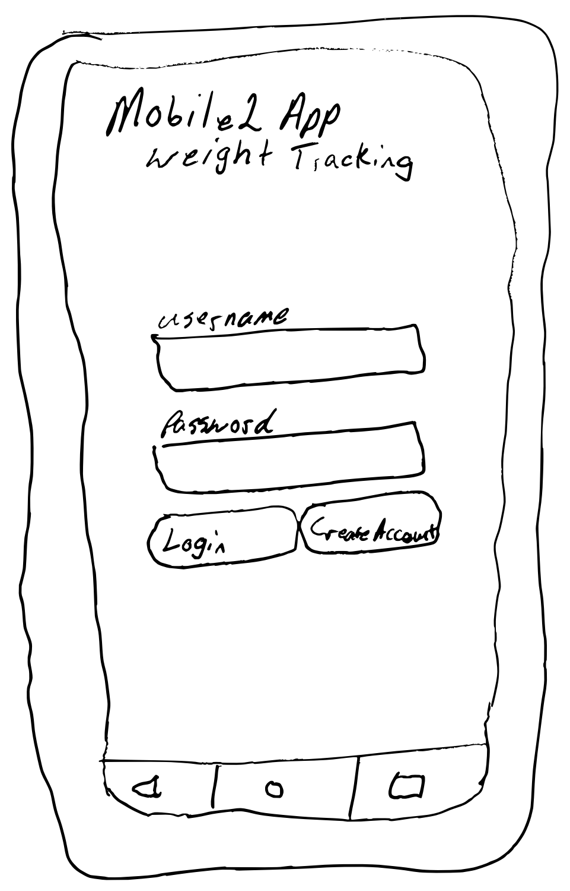

* ***Home Screen***
  + Upon first login display popup with goals and current weight prompt
    - Goals prompt will have options for gain, lose, maintain weight, and ask for a target weight.
    - First launch prompt will ask for users current weight
  + Home screen will display target weight, last weight entered, and progress from the first weight entered
  + Trend line for daily weights
  + Motivational message next to weight progress
  + Buttons for adding weight and settings

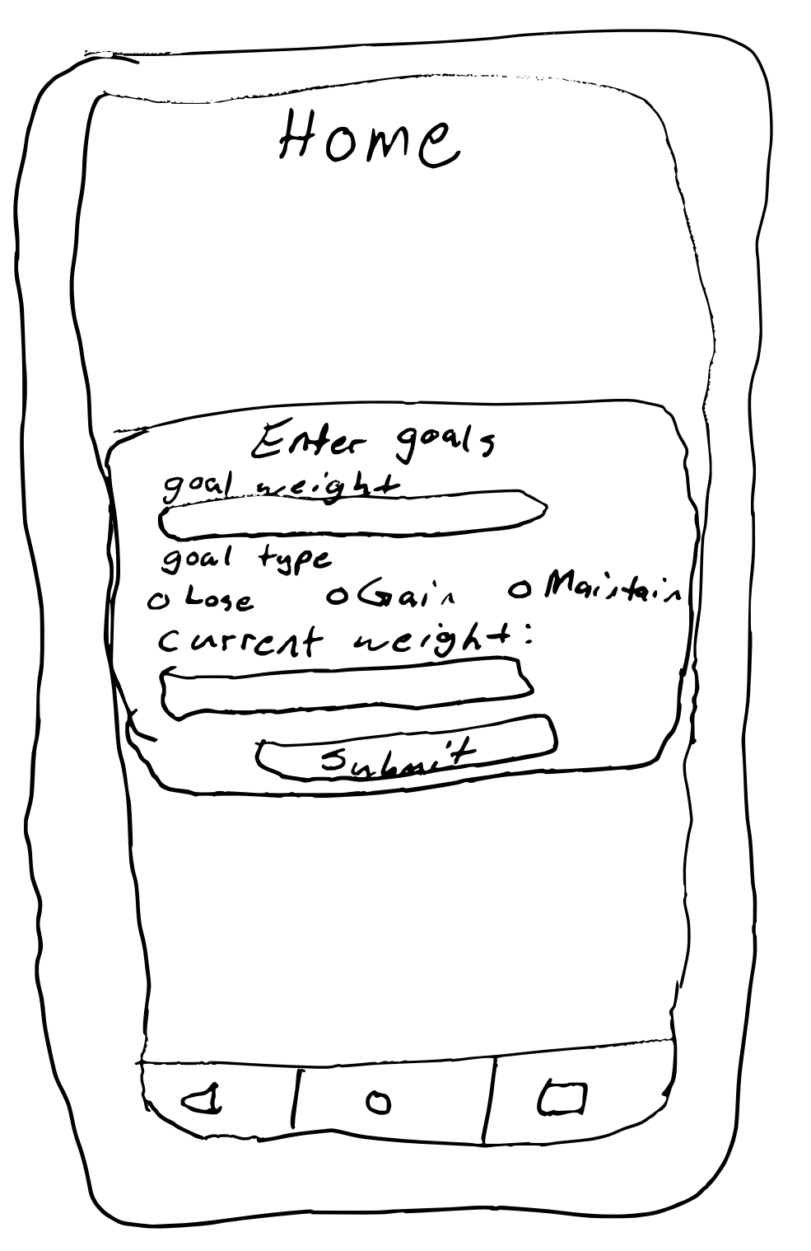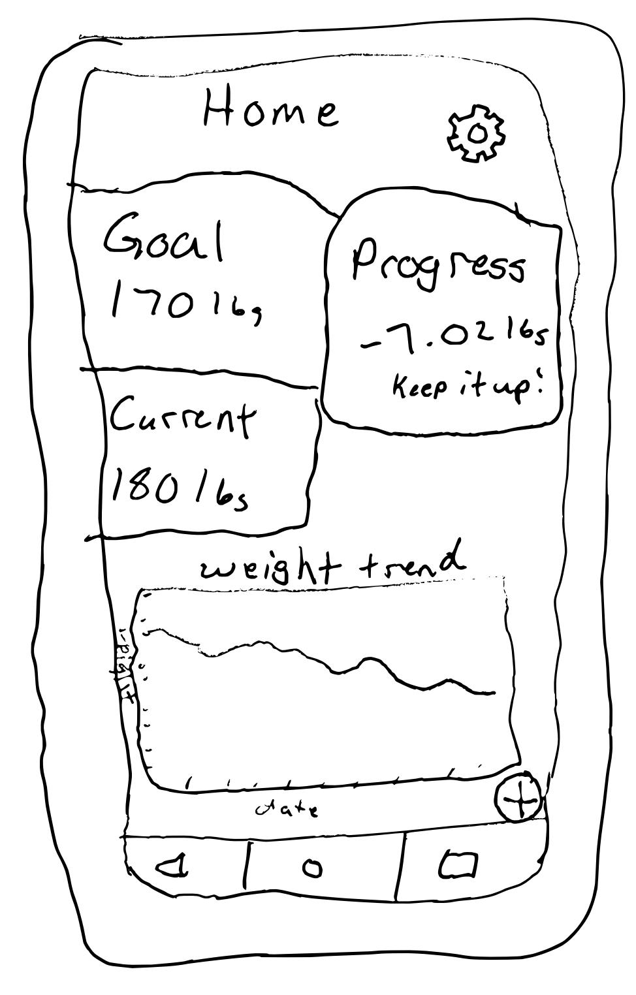

* ***Daily Weight Entry***
  + Opened after clicking add weight FAB on home screen
  + Will display a plaintext that accepts numbers and one that accepts a date that defaults to the current date

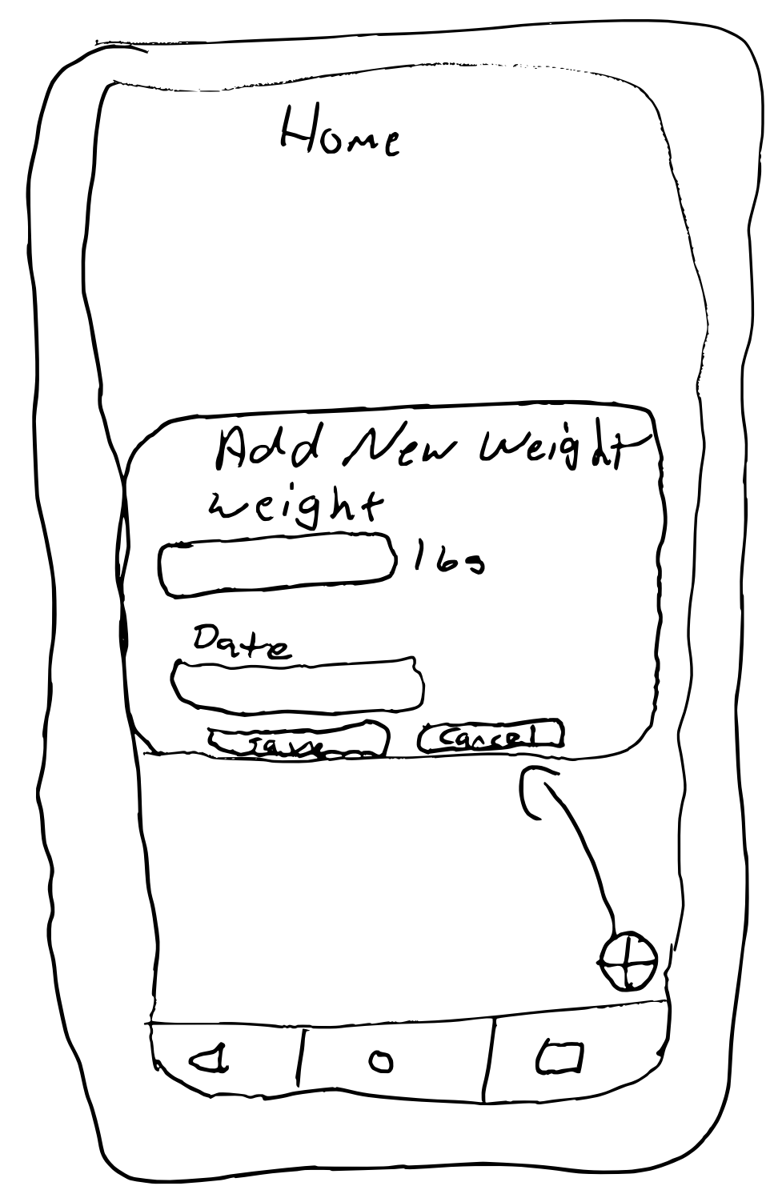

* ***Settings***
  + Will display a list of options for the user
    - **Change Goal**
      * Open screen that displays current goal type and goal weight and allows user to edit.
    - **View/Edit Weight Entries**
      * Open a screen that displays data table containing all weight entries and dates of current user. User will be able to edit or delete erroneously entered data here.
    - **Log Out**
      * Returns user to login screen and will not automatically log in upon launching application.

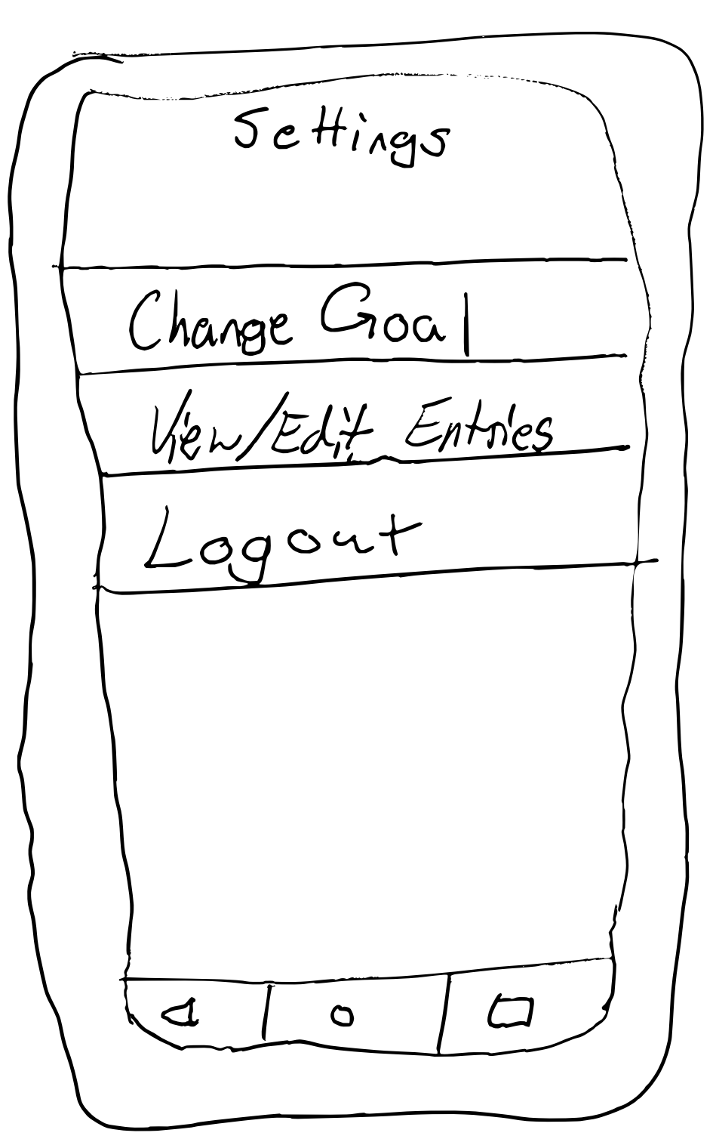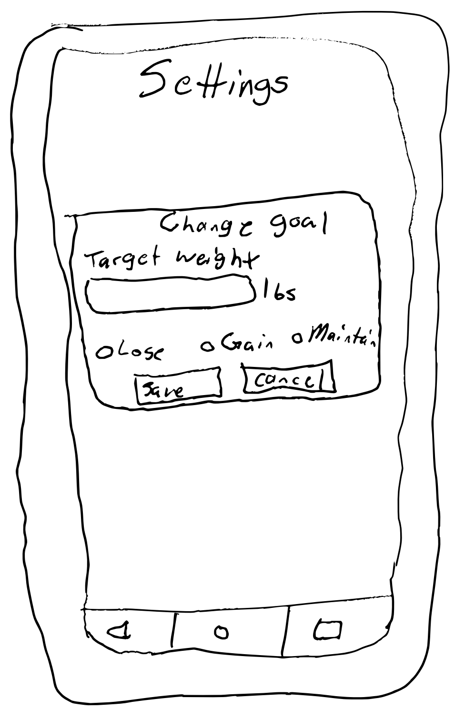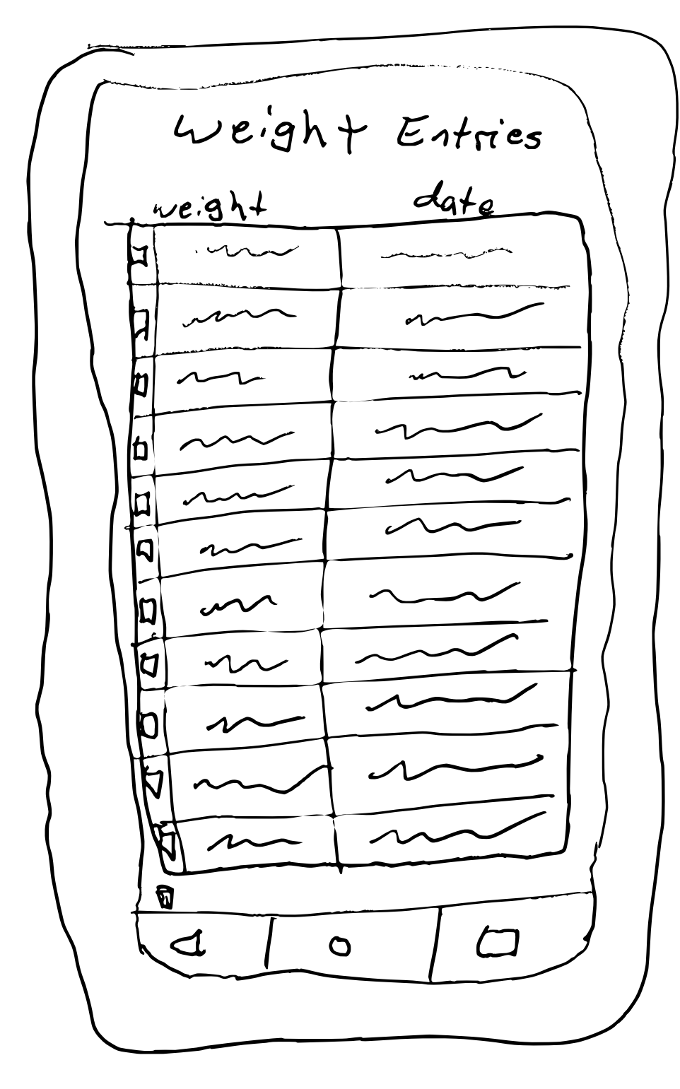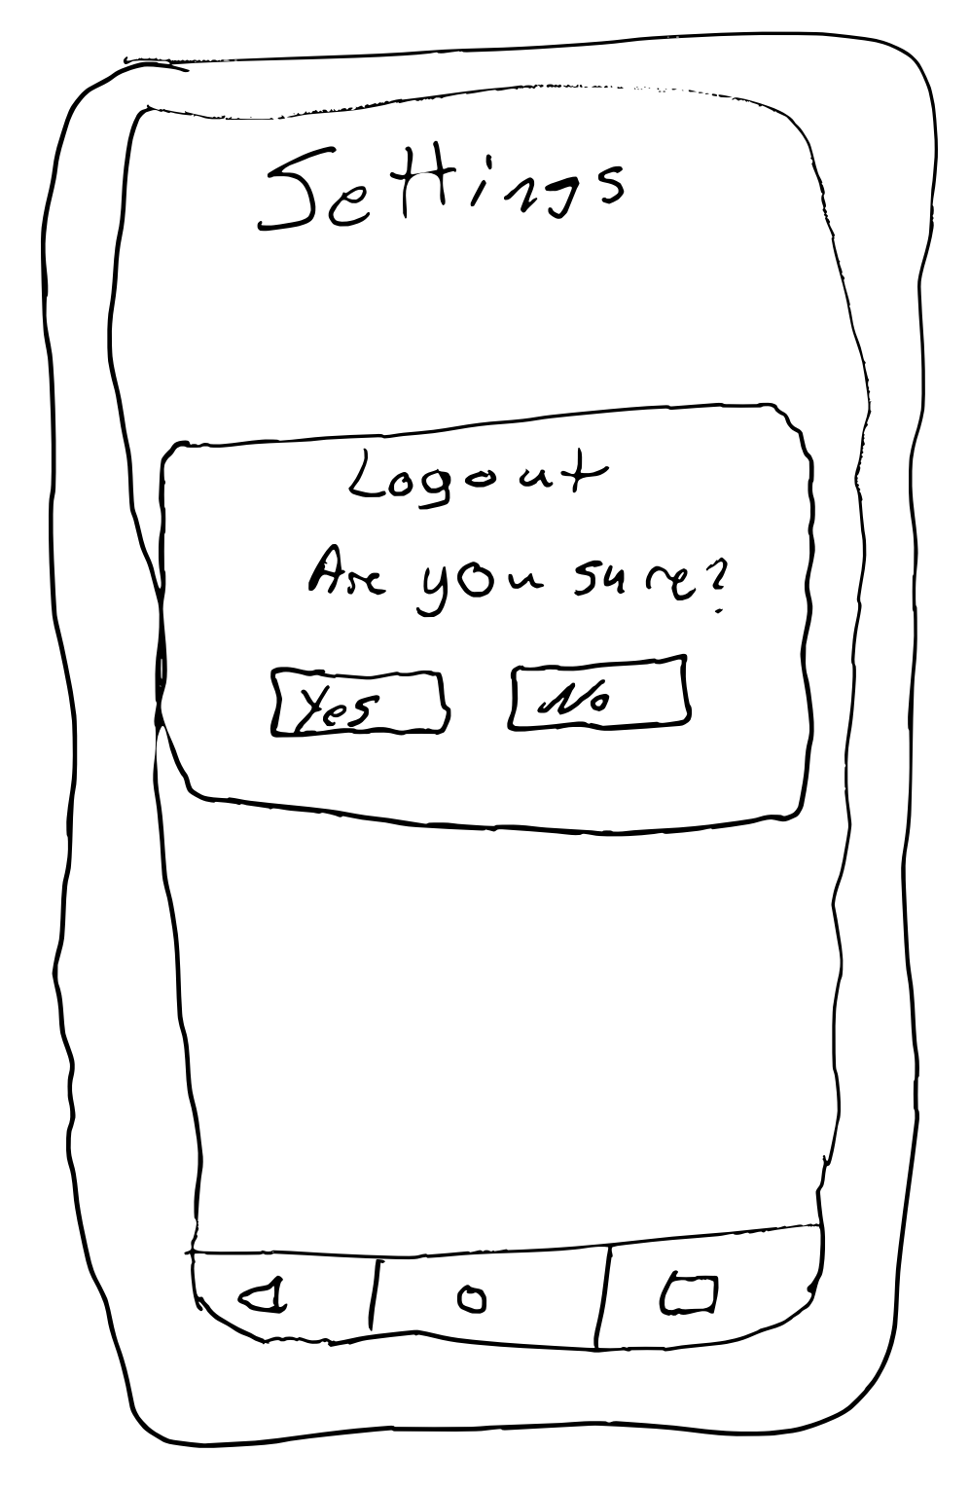

As mentioned above, the app will be centered around three data tables. The data tables will be separated into user information, user goal type and goal weight, and user weights and date entered. The first interaction with these data tables will be upon the creation of an account. Once the user creates an account and clicks submit, the username and password entered will be stored in the data table as a key-value pair to be used for future login attempts. Once the account is created the user will be able to login by entering the correct credentials into the login screen, the data entered will then be compared to the user information data table and assuming a matching username and password key-value pair is found the user will be sent to their home screen. Upon logging in, the user information table will be updated to include true flag to automatically log in.

The home screen is where most data entry and retrieval will take place. Upon first login the setup popup will be displayed to the user, and the user will enter a goal type, goal weight and current weight. The goal type and goal weight will be stored in the user goals data table and the current weight will be stored in the user weight entries data table along with the current date upon clicking submit. The major components of the home screen will be pulled from these two tables, with displaying goal weight and the newest weight of the user by looking at date entered. The trend line will be built using all entries in the user weight entries data table. Upon clicking the new entry FAB, the user will input a weight and date which will then be stored as a new entry in the user weight entries data table. Motivational text will be displayed appropriately when the user reaches a milestone, this will be determined by calling the data from the user goals data table, including goal type, and comparing it to the newest entry in the user weight entries data table.

The settings screen will have two options that allow interaction with the data tables; change goal and log out. Change goal will allow the user to freely alter their goal weight and goal type. Once a goal weight and type is selected and the save button is clicked, the user goals table will be updated to reflect this change. The log out option will log the user out and update the user information table to include a false flag on the automatic login option.

All data in the app comes from user input, which is subsequently stored and parsed as required for various functions. All data directly entered by the user will be a string (username and password), number (weight), or date. Boolean data will be used for option flags but will not be directly viewed by the user.

**Basic Data Flow**

* ***Create Account***
  + Accept two strings, username and password, then store the data in user information table.
* ***Login***
  + Accept user input strings for username and password, then search user data table for matching key-value pair.
  + Upon matching pair, set automatic login boolean to true
* ***Home Screen Goal Weight Widget***
  + Call to data table containing goal weight, then return users goal weight
* ***Home Screen Current Weight Widget***
  + Call to data table containing weight entries, return the last entry in the table based on date entered
* ***Home Screen Trend Line Widget***
  + Call to data table containing weight entries, returns a line graph constructed with all data entries (x-axis weight, y-axis date)
* **Home Screen Daily Weight Entry**
  + User input is sent to data table containing user weight entries
    - Accepts number and date as input
* ***Settings***
  + **Change goal**
    - Sends integer to user goal data table depending on which radio button is checked (0 – Lose, 1 – Gain, 2 – Maintain)
    - Accept number for goal weight
  + **Logout**
    - Upon confirming logout, changes user information table automatic login to false and destroys all screens except login screen.